The if-else-if statement contains the if-statement followed by multiple else-if statements. We can also define an else statement at the end of the chain.

Syntax:

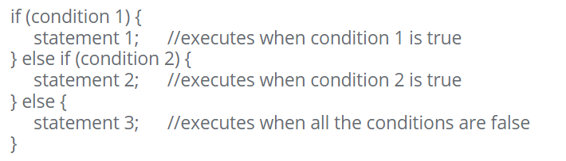

Example:

